

Ohio Aspire Professional Planning Toolkit

Sections
Introduction……………………………………………………………………1
Ohio Aspire Professional Development System……...…………………2
Professional Supports for Ohio Aspire Practitioners…………………..3

Planning for Improvement………………………………………………….11
Introduction

Professional Development (PD) is a series of ongoing, focused activities that are linked to professional and/or organizational goals. These activities are designed to develop individual professional growth and to nurture leadership. PD provides knowledge, skills, and techniques to facilitate changed behavior and promote student success and improved programs.

To assist you in meeting the Professional Development Assurances in your approved Aspire grant, the Ohio Aspire Professional Development Network (PDN), on behalf of the State Aspire Program at the Ohio Department of Education and the Workforce (ODEW), has developed the Ohio Aspire Professional Planning Toolkit. This document is intended to provide information, resources, and a process to guide you in the development of a professional development plan. It introduces you to supports available to all Aspire staff and helps you focus on your own professional growth as an Aspire practitioner.

This toolkit is designed to address the following questions.

What are the components of the Ohio Aspire Professional Development System?

What types of professional development opportunities are available for Aspire staff?

Where can Aspire staff find additional resources to help with their jobs?

What are the system tools to support Aspire programs and staff?

What communication avenues are available to connect Aspire programs and staff?

How do staff determine professional development needs and create plans to address those needs?

Ohio Aspire Professional Development System

The ODEW State Aspire Program funds a variety of quality professional development activities for Aspire staff. These activities are offered at no cost to the participant and are conducted at a variety of locations and times.

The purpose of the Ohio Aspire PD system is to provide opportunities for adult education practitioners to develop skills and gain knowledge that support improved student achievement and student transitions to postsecondary education/training and employment. It also serves to ensure that programs meet the PD requirements of the grant.

The role of the Ohio Aspire PD System is to connect the six sets of standards below into a coherent, interrelated system of quality services to adult learners.
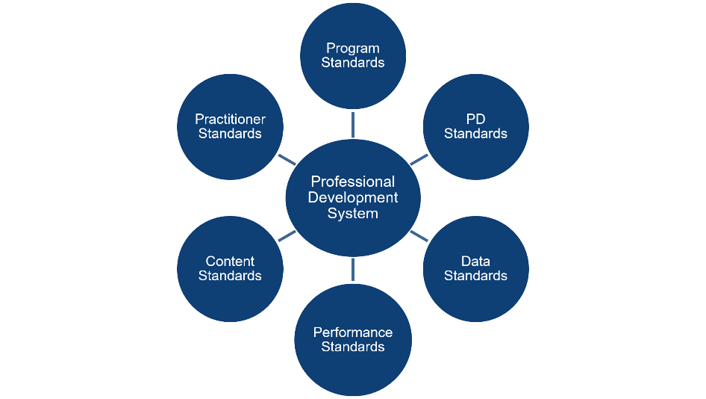

At the foundation of the professional development system are practitioner and professional development standards. The practitioner standards provide a pathway for professional growth and guide the development of high-quality activities that reflect the professional development standards. Through responsive professional development, practitioners gain a better understanding of how to implement program standards that lead to effective teaching, learning, administration, and support.

Professional development provides the tools and processes to help practitioners use the content standards for ABE/ASE and ESOL to help adult learners gain the skills and knowledge they need to reach their educational and personal goals. Through effective professional development, programs learn how to implement reliable and valid data standards that can be used to analyze progress and make necessary adjustments for continuous improvement. When these six sets of standards are fully implemented, the result is a high-quality delivery system that leads to strong student outcomes and programs that meet and exceed the performance standards.

Professional Development Policy and Guidance

In support of the Ohio Aspire PD System, the State Aspire Program at ODEW publishes a PD policy document, outlining requirements, processes, and an annual list of required orientations and trainings. The Ohio Aspire PD Policy is located on Ohio’s Aspire Program page at ODEW under Guidance and Resources.

Ohio Aspire Professional Development Network (PDN)

The State Aspire Program at ODEW established the PDN to assist local Aspire programs in developing staff skills and knowledge to increase students’ foundation skills and their successful transition to postsecondary education/training and employment.

The PDN carries out this mission by providing a comprehensive system of professional development services, technical assistance, and resources. These efforts are intended to:
- facilitate a culture of sustained learning;
- provide evidence-based, high quality, effective professional development; and
- respond to emerging state Aspire and agency professional development priorities.

Professional Supports for Ohio Aspire Practitioners

In planning professional growth, it is important to be aware of the supports and resources that exist. This section of the toolkit explains state and national professional supports available to you, such as PD system tools, communication channels, and professional organizations.

There are four key online tools to use when navigating Ohio’s professional development.

- The Ohio Aspire PDN Website (ohioaspire.org)

This state-sponsored website includes general Aspire information and resources to support program administration and instruction. In addition, it serves as the portal to other website tools. New items are added to the PDN website regularly. A few of the features on ohioaspire.org include the following.

Library – The Ohio PDN Library contains over 12,000 hardcopy resources for adult education including books, manipulatives and easy readers.

Teacher Resources – instructional resources for ABE/ASE and ESOL

Instructional Resource Collection - curated resources for all Aspire teachers including lesson plans, teaching strategies, and digital text arranged by content area for ABE/ASE or ESOL.

- The PD System at ohioaspire.org

This is the online system used to register and track professional training and events. Details about this tool include the following:

Aspire practitioners receive a distinct Aspire System ID from their program administrators.*

Aspire practitioners are responsible for maintaining the accuracy of their contact information.

Aspire practitioners use the system to register for an event or activity listed on the PD calendar.

Aspire practitioners can review their professional development, complete response forms, and access certificates through the PD history link within the system.

Aspire program administrators can add new staff members* or change staff status and roles, track staff professional development, or order materials through the Director access link within the system.

Aspire distance education (DE) staff can track previously referred students and access DE resources through the Distance education link within the system.

*Please note that Aspire staff with Director access are responsible for adding staff to the PD system. This generates an Aspire System ID for login purposes.

Registering for PD

There are three general types of professional development available through the Ohio Aspire PD System’s calendar.

Facilitated (Dated)

The PDN offers a variety of facilitated training opportunities for Aspire practitioners. Facilitated training includes face-to-face workshops and events, webinars, study circles, online courses, and book clubs. These activities have a date associated with them and can be found listed on the first page of the PD calendar. After logging in to the PD system, you can click Register at the top right to find a list of facilitated training.

Self-directed

In addition to traditional face-to-face trainings, the PDN offers self-directed PD. This utilizes multiple formats and media options for a wider variety of opportunities and allows you to work at your own pace. Self-directed PD may be in the form of a video, an online course, a webinar, a book club, or a cultural event. They do not have a date associated with them, and they are not facilitated. After logging in to the PD system, you can click Register at the top right to find a list of facilitated trainings. Then, click self-directed in the center of the page near the top to find a list of self-directed professional development opportunities.

Independent

There are a variety of other options for independent PD including site-based activities that your local institution may offer. With the endless amount of resources on the Internet, you have immediate access to lesson plans, research, teaching strategies, and a host of other valuable information.

You may also find links to free online courses designed by state and national adult education organizations as well as electronic lists and discussion groups that focus on adult education and literacy topics. By accessing the many resources on the Internet and the experience of your colleagues, you may want to conduct your own action research project within your classroom to find solutions to various challenges.

Once you have decided on an activity, you can add it to your PD history in the PD system. After logging in to the PD system, you can click Register at the top right to find a list of facilitated trainings. Then, click Register for an independent professional development activity in the center of the page near the top. Finally, fill in the details about the activity and submit it for inclusion in your PD history.

Other options for Independent PD

Read a book and write a reaction paper.

Keep a teaching journal.

Participate in a group discussion.

Take an online class.

Visit another classroom and observe a peer.

Conduct action research: The PDN Library has an entire collection devoted to staff development. You may want to investigate books on a particular topic and conduct your own action research.

Participate in a Study Circle.

Participate in site-based professional development opportunities: Your local program may also conduct or sponsor professional development activities on various topics specific to staff at your program. Be sure to check for a schedule of any PD activities that are being planned for your program.

Present an instructional idea to your peers.

Participate in mentoring/coaching.

Participate in special projects identified by ODEW or the PDN.

Additional Online Courses and Webinars

The following organizations offer online courses or webinars for additional professional development options.

ETS (HiSET)

GEDTS

LINCS

NAASLN

New Readers Press

ProLiteracy

TABE

TESOL International Association

World Education

Additional Options

Take online courses and gather classroom activities and research from LINCS (Literacy Information and Communication System), a professional learning community for adult educators that provides access to resources, professional development, and research on adult education.

Courses allows access to self-paced online courses for adult education practitioners.

Resource Collection are online subject-oriented collections of high-quality instructional resources, including multi-media resources, informed by research, especially scientifically based and other rigorous research, for use by adult education and literacy educators.

Federal Initiatives provide evidence-based practices for instructing adult learners.

Participate in study circles where teachers discuss issues and solve issues. The National Center for the Study of Adult Learning and Literacy (NCSALL) developed some excellent study circle guides on topics, such as learner persistence, research-based reading instruction, adult development, and multiple intelligences theory. You can view descriptions of these by clicking here.

PD Portfolio

The Ohio Aspire PD System is designed to track and maintain an electronic record of your professional growth during your time in Aspire. The PD History feature maintains all certificates for training that you register for through the PD System. This can help you build your professional portfolio. Note, your program director can also access your PD history to view completion status.

It is important for you to maintain these certificates for future use, such as applying for licensure renewal, or after your time in Aspire as the PDN does not reissue them.

- The Ohio Aspire PDN Moodle (ohioAspire.org/online)

This Moodle is the Ohio Aspire PDN’s learning management system for self-directed professional development, such as online courses, Communities of Practice, and resource sharing. It houses the New to Aspire Orientation training series, required online courses plus a variety of elective courses. A separate login is required, but your account is created for you.
- Register for PD in the PD system and then access it in the Moodle.
- Your Moodle account credentials are sent to you in a separate email.

The Ohio Aspire PDN Library (http://ohioAspirelibrary.org)

This hardcopy library includes adult education instructional and professional development resources available for preview purposes. Your library credentials are the same as your Aspire PD System ID, which you can use to search for and reserve books online. Then, PDN staff will mail available items to you with a postage-paid return label. Learn more in the Ohio Aspire PD System User Guide or contact the PDN librarian directly at library@ohioaspire.org.

Ohio PDN Online Tools Quick Reference

The Ohio Aspire Website Reference Chart is a graphic to explain the correlation of the Aspire websites and their content. You can record your login information for the PD System, Library and Moodle then save it as a resource or print a hard copy. A downloadable copy of the chart is included at the link above.

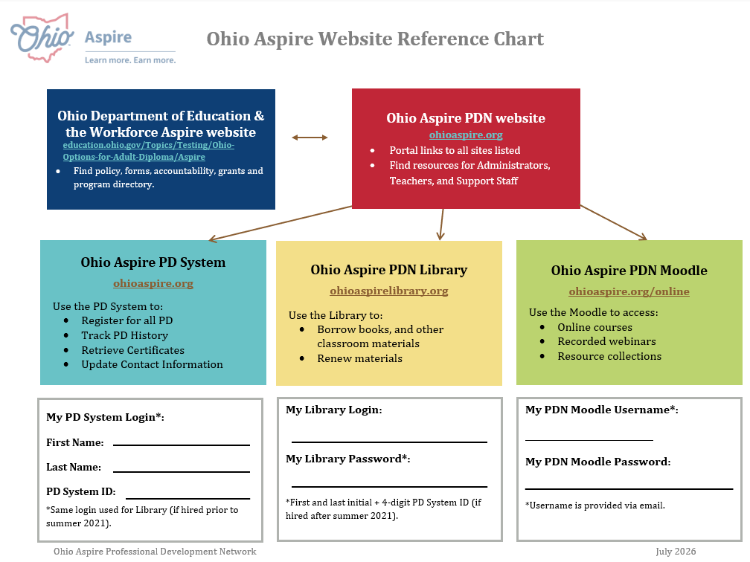

Communication and Technical Assistance

To streamline technical assistance, the PDN maintains a central PD “hotline.”

The general contact information for the PDN is listed below.

Phone: 800-765-2897, option 2
Email: ohiopdn@literacy.kent.edu

In addition, there are a variety of other methods for communication and technical assistance as follows.

Resource Type | ODEW | PDN
Website | education.ohio.gov/Topics/Testing/Ohio-Options-for-Adult-Diploma/Aspire | Ohioaspire.org
Main email | aspiregrants@education.ohio.gov | ohiopdn@literacy.kent.edu
Email Lists | Statewide .gov (Administrators) | OhioLit (All staff)  ESOL (ESOL staff)
Web Conferencing* | Teams | Zoom
Aspire Calendar | State calendar education.ohio.gov/Topics/Testing/Ohio-Options-for-Adult-Diploma/Aspire | Training Calendar  ohioaspire.org  In the PD System
Aspire Program Directory | education.ohio.gov/Topics/Testing/Ohio-Options-for-Adult-Diploma/Aspire/ Program Directory

*Web Conferencing

Many professional development opportunities are available via webinar or web conference. The State Aspire Program at ODEW and the PDN use platforms with similar components.

Check Equipment: Please make sure you have a working microphone and speakers/sound. For example, a headset would be sufficient. If you don’t have access to sound and video, your program may provide the devices for you. If your program is unable to provide the needed devices, please contact the PDN and we may be able to assist you.

Zoom platform: The Zoom Learning Center has short informational videos. If you are not familiar with Zoom basics, we recommend you take a few minutes to view the Zoom Meetings video(s) prior to your training session.

Professional Organizations and Additional Resources

Professional organizations are non-profit agencies organized to support you and your profession. Many of interest to adult educators provide leadership, communication, professional development, and advocacy for adult education and literacy programs and their staff.

Annual Conferences

Each organization conducts and/or sponsors professional development conferences and activities that provide a forum to provide staff development and to advance adult education and literacy. Annual conferences provide great hands-on workshops and activities. Attending is a great way to enhance your professional growth and network with other education professionals who face the same challenges.

Two popular state conferences held in the fall are:

OAACE (Ohio Association for Adult and Continuing Education)

Ohio TESOL (Teachers of English for Speakers of Other Languages)

Three of the most popular national conferences for adult educators are those conducted by:

COABE (Commission on Adult Basic Education)

TESOL International Association (Teachers of English to Speakers of Other Languages)

ProLiteracy America

Additional Resources

ACTE (Association for Career and Technical Education)

A national association representing thousands of career and technical education professionals. ACTE provides educators with powerful resources, professional development and information to help them achieve. The annual conference is typically held in the fall.

Ohio ACTE (Association for Career and Technical Education)

The state agency that represents teachers, administrators, advisors, staff and adult educators throughout Ohio. The annual conference is typically held in the summer.

Ohio Educational Technology Conference (OETC)

As a state agency, OETC is dedicated to enhancing learning by developing programs and using best practices to serve learning organizations while acquiring, integrating, and sustaining educational technology. The annual conference is typically held in February.

Planning for Improvement

This section of the toolkit focuses on planning for improvement using tools such as a self-assessment, reflection, and a professional growth plan.

Self-Assessment

In PD planning, it is always good practice to reflect on strengths and weaknesses in order to identify needs. The Ohio Aspire Practitioner Standards can be used for self-assessment and to identify areas for growth and further professional development.

Additionally, the Classroom Observation Worksheets within the Program Review Instrument can serve as a self-assessment tool that can help you consider your professional growth and PD options.

Reflection

As referenced in this toolkit, you have a variety of opportunities to strengthen or fine-tune your professional skills. How do you decide what to select? Planning your professional development should be a reflective process, one in which you and your program administrator or another staff member match your professional needs and interests to the most appropriate venue. Two sources of information that could inform your plan are data and resources.

Data

In preparation for completing your professional growth plan, please consider:
- your Aspire program’s Program Improvement Consultation Plan (PICP);
- the practitioner standards for your role in Aspire;
- training requirements for your role as outlined in the Aspire PD policy;
- the results of your self-assessments;
- your personal professional goals; and
- the needs of your students and your ability to facilitate their learning.

Resources

In preparation for completing your Professional Growth Plan, you may want to consult:
- the Ohio Aspire PD system’s training schedule of facilitated, self-directed, and supplemental and complementary courses
- professional organizations for scheduled events
- the Internet for additional self-directed, online professional development opportunities and resources

Professional Growth Plan

A professional growth plan is a plan that is customized to your career goals, which should be aligned to those of the State Aspire Program at ODEW as well as the specific goals identified by your program within the Program Improvement Consultation Plan.

Upon completion of the New Staff Orientation and the specific modules for your role in Aspire – New Administrator Orientation, New Teacher Orientation, or New Support Staff Orientation – you may want to complete a professional growth plan to outline your next steps for professional development.

Plans may vary in format, but the following elements are important to include:
- Program goals (aligned to Aspire priorities)
- Professional goals and timeframe for achievement
- Professional development activities and resources needed
    - State Aspire Program required training
    - Other training or professional development activities

Record of Accomplishments

As you begin to implement your plan and participate in professional development activities, here are three questions to guide your process.

What did you learn?

How will you apply this learning?

What questions do you still have?

Responding to these questions will help professional development become an ongoing process in your professional practices with adult learners.

Create Your Plan

Once you have completed a self-assessment, reviewed your data, and consulted necessary resources, you are ready to create your professional growth plan and set your professional goals for the year.

The following page contains a sample form that you could use for your plan.
Professional Growth Plan
Name |  |  |  |  | Position
Program |  |  |  |  | Fiscal Year
Program goals
Goal 1 |  |  |  |  | Goal 2
Professional Goals |  |  |  |  | Record of Accomplishment
Goal 1
 | Professional Development Activities | Timeframe |  | Resources | Achievement  (work/status) |  | Reflection  (next steps)
Goal 2
Signature |  |  | Date |  | Comments
Supervisor |  |  | Date |  | Comments

